Modeling Thomas De Colmar’s Arithmometer

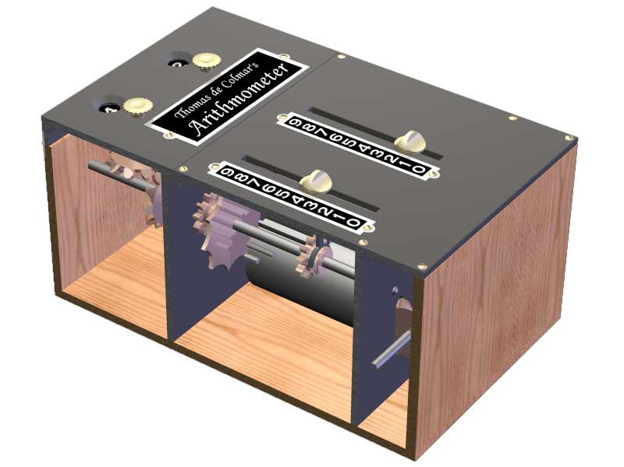

Tim Kostka, Fall 2004

Table of Contents

Table of Contents 2
Table of Figures 3
Objective 4
Objective 4
Background 4
Working of the Device 4
Step gear 4
Carry mechanism 4
Procedure 5
Simplifications to the model 5
Creating the model 5
Printing the model 6
Results 6
Summary 7
Recommendations 7
Acknowledgements 7

Table of Figures

Figure 1: The Thomas de Colmar Arithmometer 8
Figure 3: Picture of the SolidWorks model 10
Figure 4: Picture of the rapid prototyped model 11
Figure 5: The inscription and numbers on the device 12
Figure 6: The writing and step gears 13
Figure 7: An overview of the carry mechanism 14
Figure 8: Play associated with the sliding gear 15
Figure 9: Part of the carry mechanism of the device 16
Figure 10: The locking mechanism and reset ramps 17
Figure 11: The back of the device 18
Figure 12: The upper carry slider being pushed into the engaged position. 19

Objective

The objective of the project was to create a SolidWorks model of Thomas De Colmar’s Arithmometer and make this model freely available to outside universities and groups. The end result would be to provide the capability for anyone to print a model of the device at a cost significantly lower than the price of buying a machine. Since outside companies exist for the rapid prototyping to be outsourced, money the only resource needed for a group or individual to obtain a model.

In modeling the Arithmometer, significant attention was paid to the goal of rapid prototyping the model. This included looking at the design from a reliability standpoint as many parts fabricated out of metal would break if fabricated from plastic. The aesthetics were also a point of interest as the model would be utilized more for its visual characteristics than its functionality.

Background

The Arithmometer, designed by Thomas de Colmar, was the first commercially successful calculating device (Figure 1). It was initially produced in the 1820’s and continued to be successful until the 1930’s. The Arithmometer was capable of adding or subtracting ten digit numbers and had an output register capable of holding a sixteen digit number. The pictured device was produced well after 1820 and contains a number of improvements for reliability but the fundamentals of the design remained unchanged throughout its lifetime.

Working of the Device

The operation of the Arithmometer is the result of a number of different devices used to provide the functionality of the entire device. The two key elements of the device are outlined below.

Step gear

Each input digit place has a step gear associated with it. All of the step gears are turned simultaneously via a power axle which is turned by a handle.

The step gear used has nine teeth which extend various lengths along the axial position of the gear. By meshing this step gear with a gear which is able to slide into any of these positions one can achieve a gear ratio of 0:10, 1:10, 2:10, …, 10:10. That is, for one turn of the step gear, the mating gear (which is coupled to the number wheel) will turn by 0 to 10 teeth. By selecting the position of the mating gear based on the number one wishes to add, this produces the adding mechanism of the device.

Carry mechanism

When the ones digit travels from 9 to 0, an extra number must be added to the tens digit. This is done by way of a series of components which make up the carry mechanism (Figure 11 and Figure 6). This mechanism is triggered only when the digit moves from 9 to 0 and is reset on each turn so it functions correctly. The series of events which trigger this are outlined below.

1) The ones digit moves from 9 to 0. This causes a protrusion on the bottom of the number wheel to push against the upper carry slider which in turn pushes on the carry lever which pushes the lower carry slider from the disengaged position into the engaged position (Figure 8).

2) The tens digit is increased by one. The tooth on the lower carry slider meshes with a gear on the main axle to rotate the axle by 1/10 of a turn and increase the digit by one. This tooth should be aligned where the 10th tooth on the step gear would be in order not to interfere with the step gear operation.

3) The carry mechanism is reset. The upper and lower carry sliders are reset by mating ramps on the slider and the housing. Over the course of the rotation, these ramps touch and push the lower slider back into its disengaged position which in turn also resets the lever and upper slider.

Procedure

Cornell does not currently own an Arithmometer based on Colmar’s design. Without the ability to experience the device first hand we had to rely on interpreting drawings to figure out how the device works. Although electronic copies of the original patent document created by Colmar are available, the images are of too poor quality to discern specific details.

The capability to model the device comes from technical drawings made by Franz Reuleaux during the 1860’s. This model was clearly modified from the original device and shows several changes primarily for reliability and convenience. However, the basic functional components of the system, the step gear mechanism and the carry mechanism, have remained the same. Since the drawings do not have detailed dimensions, the drawings were measured and the scale was assumed to be 1:1. The final model has dimensions close to an actual device.

Simplifications to the model

A number of simplifications were necessary to produce a functional model. First, only two of the digit places were modeled. By modeling only two, the model was significantly decreased in size while still incorporating all of the primary components. The two digit places contain two step gears and one carry mechanism. This decision allowed us to focus on the mechanics of the one carry mechanism instead of looking at eight copies of it simultaneously.

Additionally, the model was simplified by not including all of the features of the original design. The reset slider, which sets all digit places to zero with the motion of one slider, was not modeled. The ability to set the device in both addition and subtraction mode was also not modeled.

Creating the model

A model of the device was created using SolidWorks. The dimensions for the device were taken directly by measuring the drawings. With each component, attention was paid to the rapid prototyping goal for the model. The axles were increased in size for strength and torsional stiffness. The gears that couple the power axle to the step gears and the gears that couple the main axle to the vertical number wheel axle were designed to have a smaller number of larger teeth to increase strength while sacrificing precision.

In order to improve the clarity of the model, the top plate which covers the step gears was left open. Therefore, the slider to select the different digits is missing and so the digits must be selected by manually moving the gear. For the same reason, the plate covering the number wheel (Figure 4) is partially open but the current digits are apparent.

Also in order to better design the model for use in rapid prototyping, changes were made to simplify the carry mechanism. The carry lever was moved to the opposite side of the center plate and the upper carry level was introduced as a means for pushing against the lever. The lever in the model pushes directly against the lower carry lever while in the original design there is an additional component to do this. This simplification also allowed the tooth on the lower carry lever to be much stronger and better supported. In the original design, this tooth is significantly smaller and would likely have broken under operation of a rapid prototyped model had the design not been changed.

The computer model can be seen in Figure 2.

Printing the model

Once the SolidWorks model was created, it was exported as a stereolithography file (.STL) for use in rapid prototyping. Rapid prototyping is a process in which a three dimensional part or device is made by printing many very thin two dimensional layers built on top of each other. The model is printed using two materials. The filler material is used in positions where gaps are in the model and can be dissolved away in an ultraviolet bath. The end result in this project is a tree dimensional fully functional model composed of many parts with absolutely no assembly needed. More information on rapid prototyping can be found online.

Results

The device was printed on a rapid prototype machine and took roughly 90 hours to print. The development step of the process took longer than expected. Even with drainage holes designed to aid development, it took four two-hour baths before the filler was sufficiently dissolved so that the components were no longer locked up. However, because of the long print time, the eight hours it took to develop is not a big consideration.

Overall, the model works surprisingly well. The power transmission axle which connects to the two step gear axles has no problems. The handle and the teeth of the gears seem sufficiently strong.

The major problem with the device deals with the timing for the carry mechanism. The tooth on the carry slider (Figure 8) should be in the position after the last tooth on the step gear. In the model, it is just before the eighth tooth, roughly 45 degrees out of place.

Another problem is the alignment of this tooth with the gear. The lower carry slider should move so that the tooth is completely disengaged with an acceptable clearance when the carry mechanism is not engaged. In the rapid prototyped model, the carry mechanism should not be engaged but the tooth and gear slightly overlap (Figure 8). When the mechanism is engaged, seen in the two have acceptable meshing.

There is considerable play between the sliding gear and the main axle (Figure 7). The gear can rotate about 20 degrees while holding the main axle still. This is due to the gap required in the rapid prototyping process, but a solution should be found such that the two components cannot rotate this much with respect to each other.

The upper carry slider can be in a position so far toward the number wheel that the protrusion on the bottom of the number wheel hits the slider on the side and not on the end. This causes the model to lock up. Although this is a smaller detail, the upper carry slider should be constrained to its intended travel length.

The main axle sometimes locks up due to the friction at the very end of the axle towards the number wheel. Since none of the other axles lock up in any position, this may be due to the drainage holes on the axle added to aid with development.

Summary

The project succeeded at producing a model that captured the basics of the original device, however the functionality of the model has room for improvement. While this functionality is important, it should also be realized that this model is intended for historical and academic interests rather than commercialization and thus aesthetics are an important issue. The open areas on the top and sides of the model serve and excellent job of allowing the viewer to observe all parts of the model. No parts of the model appear to be too weak to the point of breaking.

Recommendations

A second version of the model should be created incorporating fixes for the problems addressed above. The problems and possible solutions are summarized below.

The timing on the carry mechanism needs adjusted. The tooth on the carry slider needs to be adjusted by approximately 45 degrees. The tooth should be in the position that a tenth tooth on the step gear would be.

The switching mechanism should be adjusted so that the carry tooth and gear are switched between being entirely disengaged and meshed. This entails increasing the amount of travel the carry slider moves and also increasing the size of the reset ramp used to push the slider into the disengaged position.

The sliding gear and the main axle have too much play with respect to one another. This can be solved by printing the sliding gear in the zero position and changing the indentations between the numbers into raised bumps. This way there will be less freedom between the components bringing them closer in phase. Ideally, the height of the bumps should be enough to cause enough friction to keep the slider gear from changing positions on account of its own weight.

The drainage holes on the main axle should be removed. If necessary, additional drainage holes can be added to the protrusion on the housing at a location which is not a contact surface between the two parts.

Cosmetically, the “Cornell” inscription on the front of the model can be made larger. Also, the modeler’s inscription on the back of the device should be increased in size as it is hard to read.

Acknowledgements

Francis Moon - for his knowledge of calculating machines and for providing the inspiration for the project.

Hod Lipson - for his expertise on rapid prototyping and for providing the rapid prototype machine used to print the model.

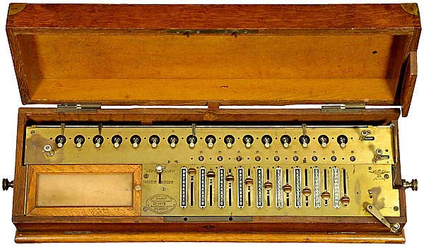
Figure 1: The Thomas de Colmar Arithmometer. This particular device was produced by a successor of de Colmar.

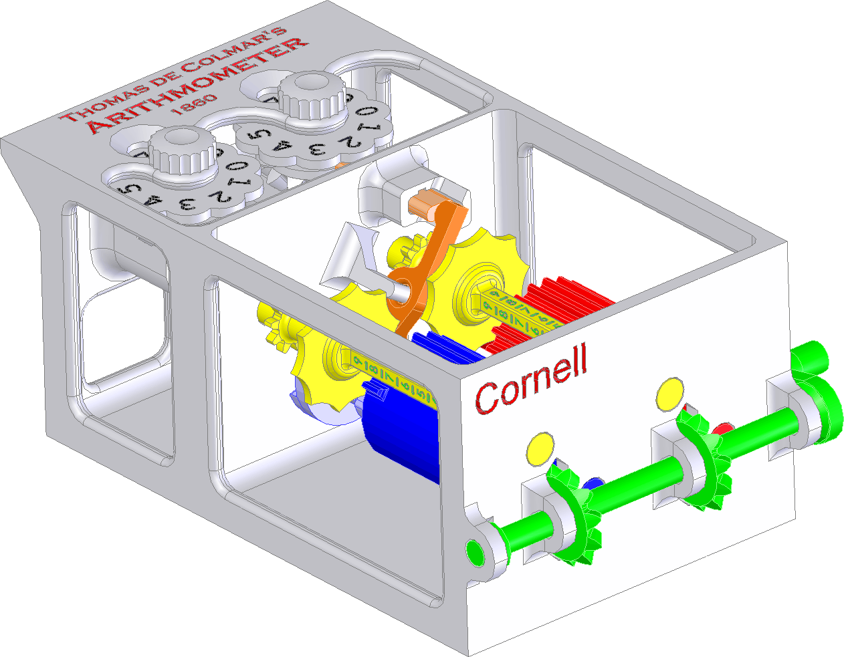
Figure 2: Picture of the SolidWorks model.

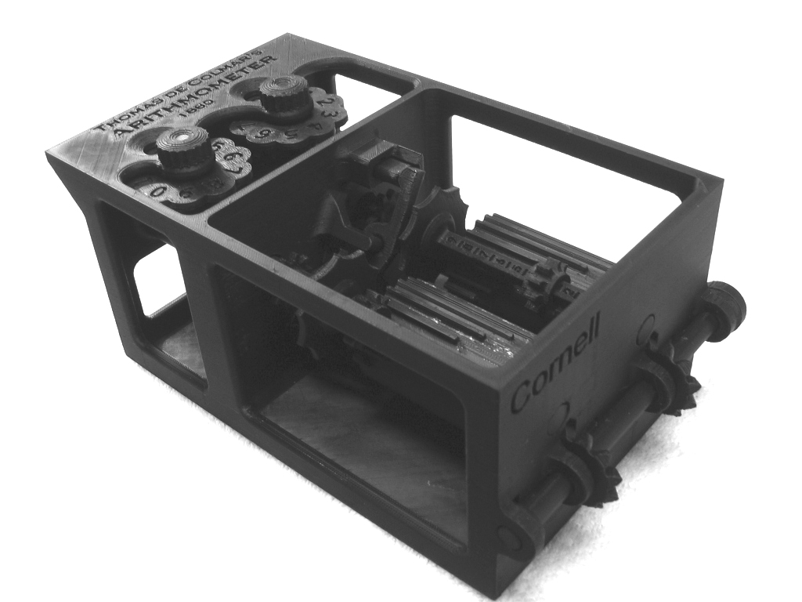
Figure 3: Picture of the rapid prototyped model.

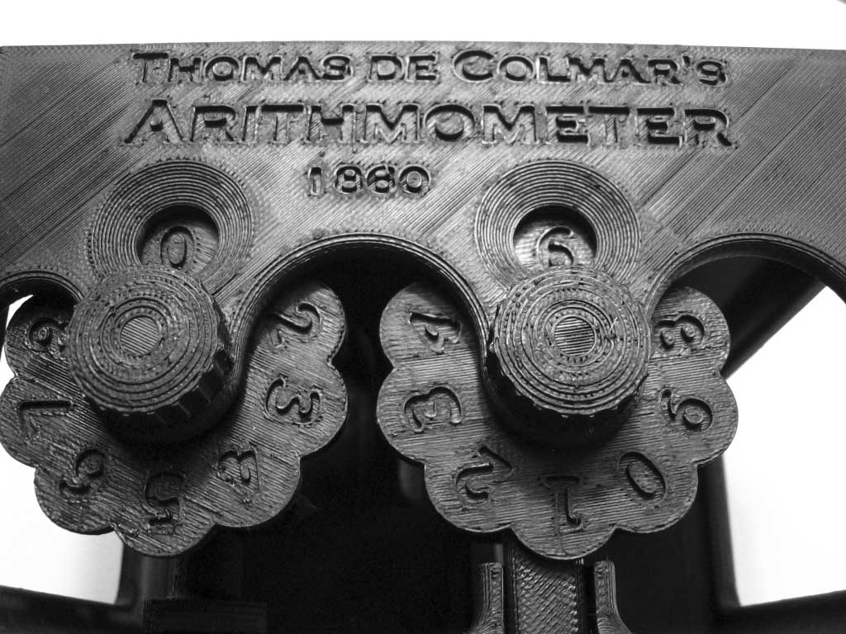
Figure 4: The inscription and numbers on the device. Note that the cover on the original device was completed closed. It was made open in the model to allow the inside components to be seen. The current output number is still apparent (06 in this picture).

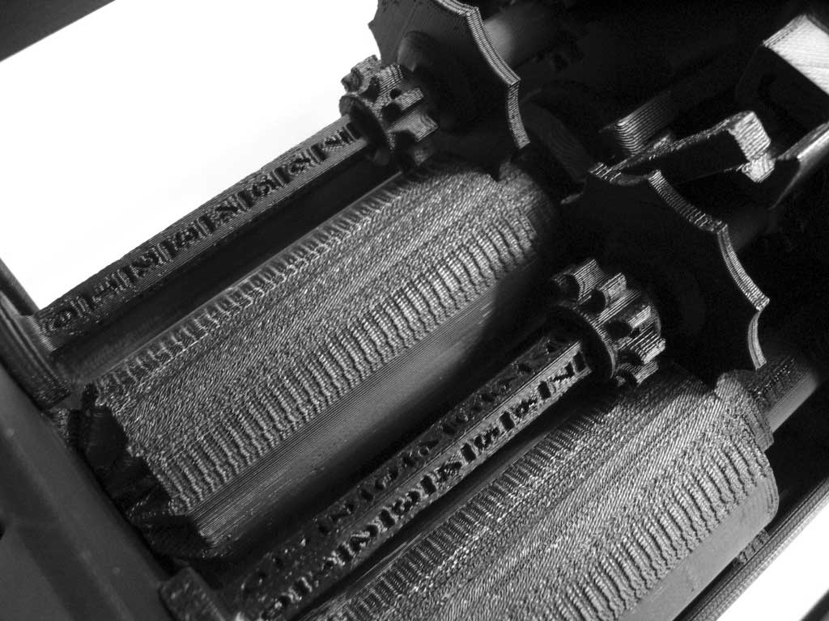
Figure 5: The writing and step gears. In the original device, there would be a cover on this compartment with sliders to move the gears into the various number position. The cover and the digit sliders were not modeled to improve visibility of the components.

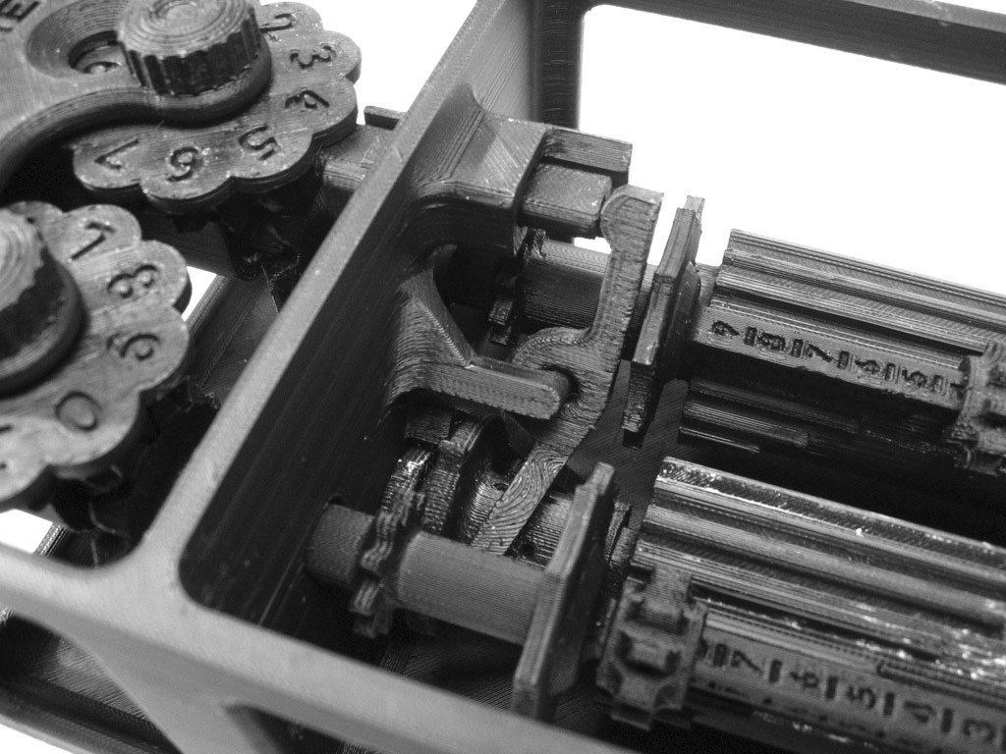
Upper Carry Slider
Carry Lever
Lower Carry Slider
Figure 6: An overview of the carry mechanism.

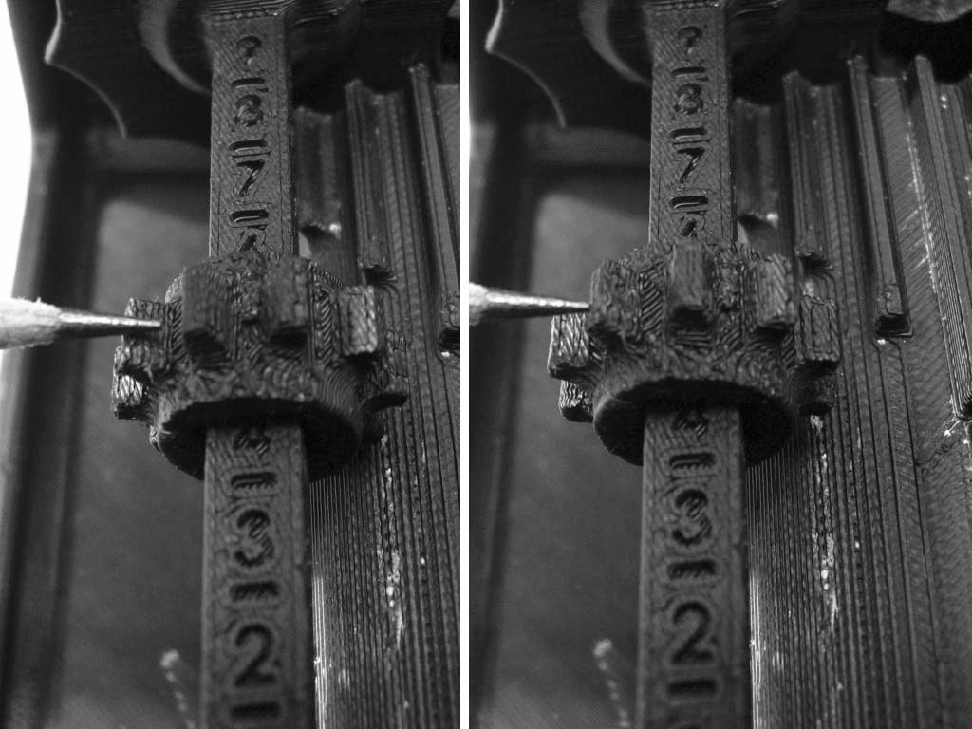
Sliding Gear
Main Axle
Figure 7: Play associated with the sliding gear. Notice how much the sliding gear is able to rotate independently of the main axle. This affects the timing of the entire mechanism.

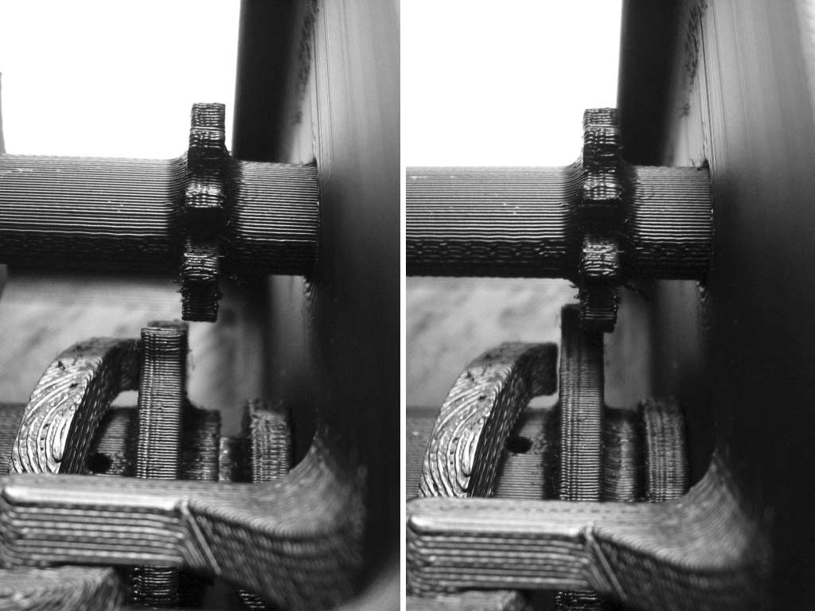
Figure 8: Part of the carry mechanism of the device. When disengaged (left), the gear and tooth should be entirely separated. In the engaged position (right), the two should be entirely overlapped.

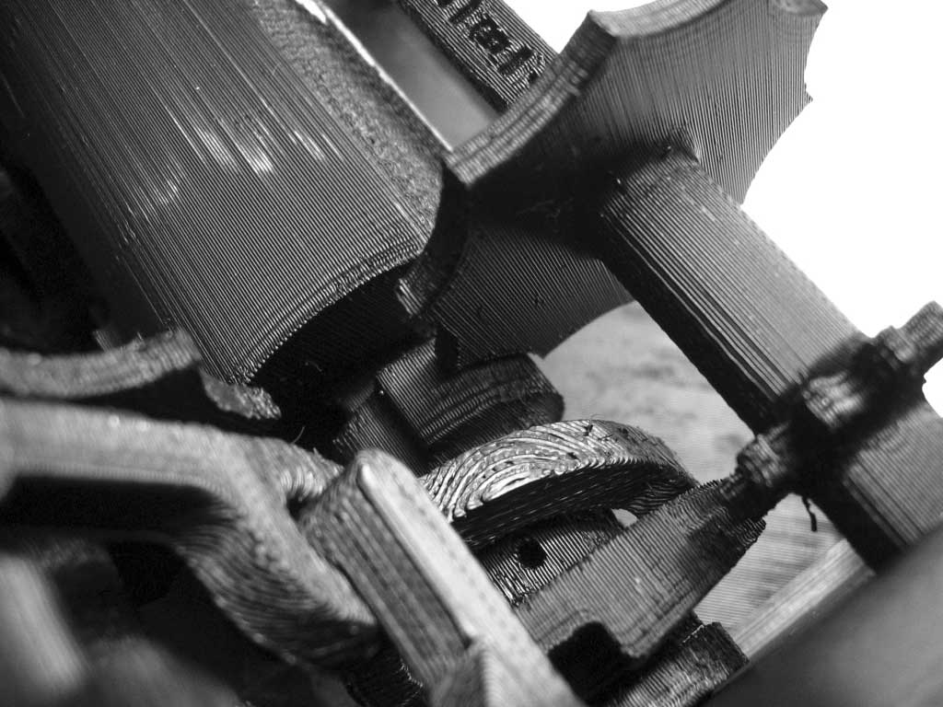
Figure 9: The locking mechanism and reset ramps. The lock prevents the digits from changing during the inactive portion of the rotation. The reset ramps push against each other and allow the lower carry slider to reset.

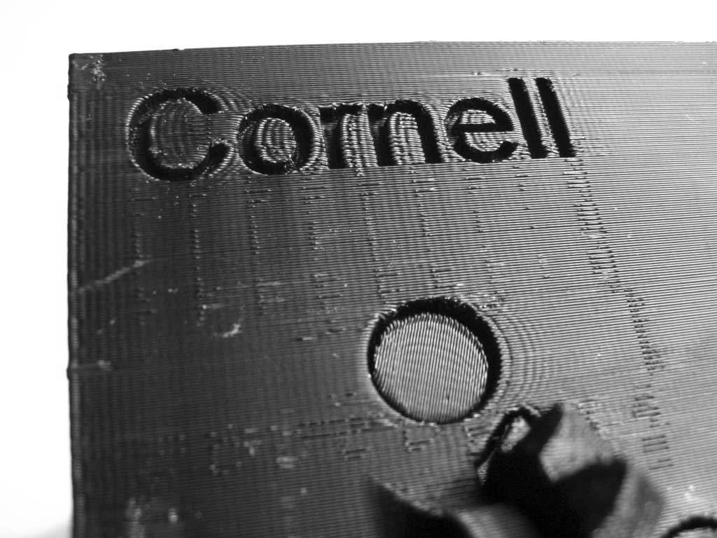
Figure 10: The back of the device. Notice how much play there is at the end of the axle.

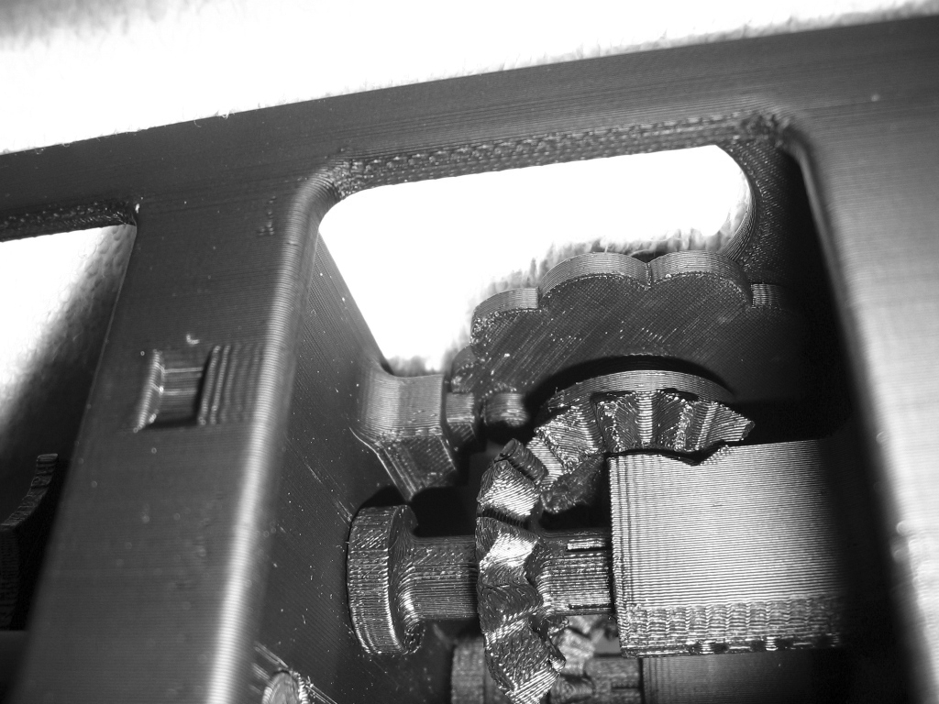
Figure 11: The upper carry slider being pushed into the engaged position.

